**Run web application:**

* Open Anaconda prompt from the start menu
* Navigate to the folder where your Python script is.
* Now type the “app.py” command
* Navigate to the local host where you can view your web page.
* Click on the inspect button from the top right corner, enter the inputs, click on the predict button, and see the result/prediction on the web.

Then open your browser and go to:

( <http://127.0.0.1:5000/>) to get results.

UI Image preview:

Let’s see what our index.html page looks like:

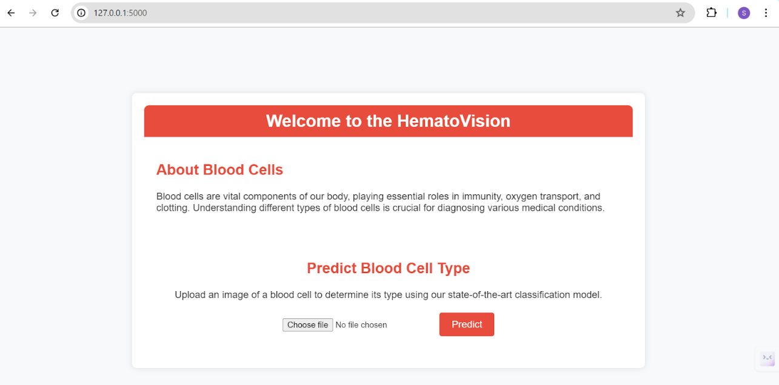

By clicking on choose file it will ask us to upload the image , then by clicking on the predict button , it will take us to the result.html

Test For Class-1 : Neutrophil

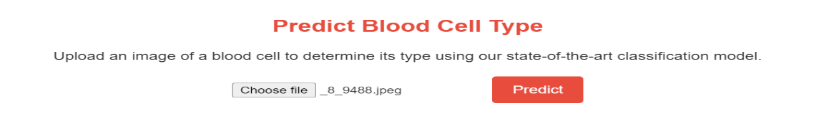

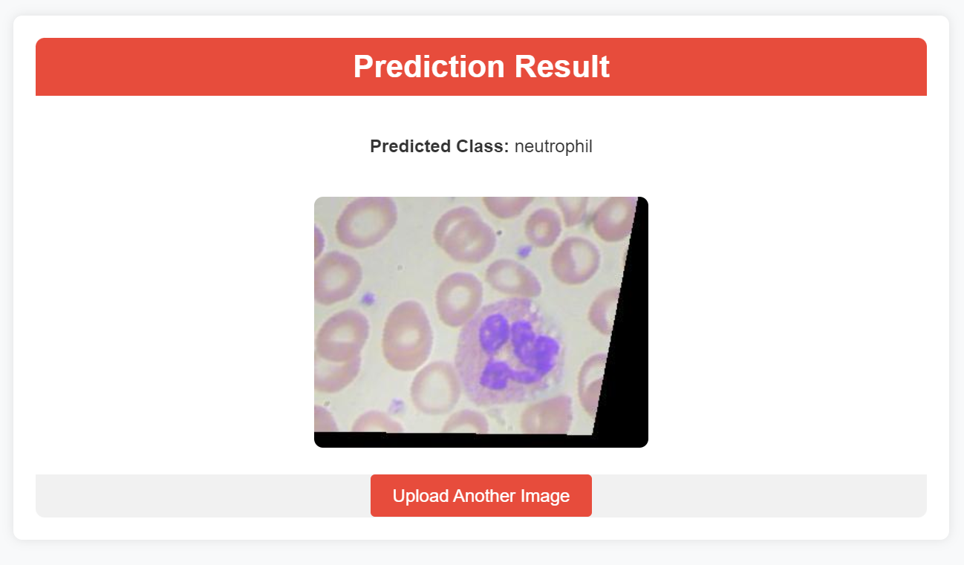

Test For Class-2 : Monocyt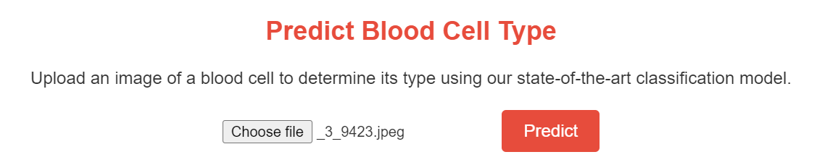

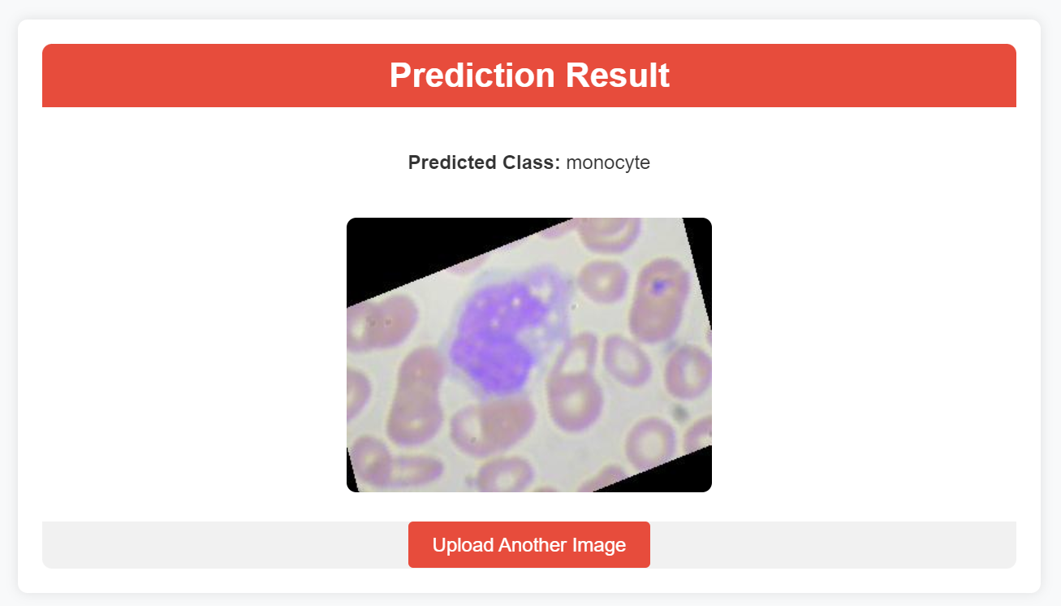

Test For Class-3 : Lymphocyte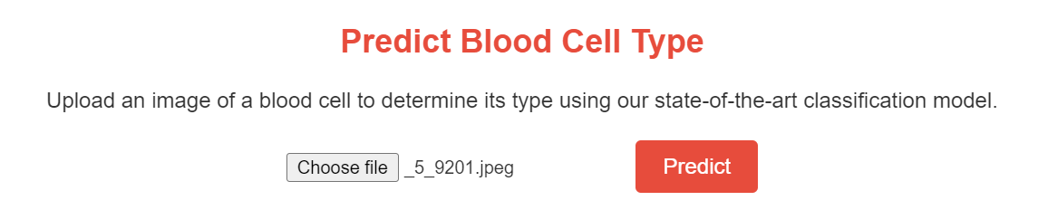

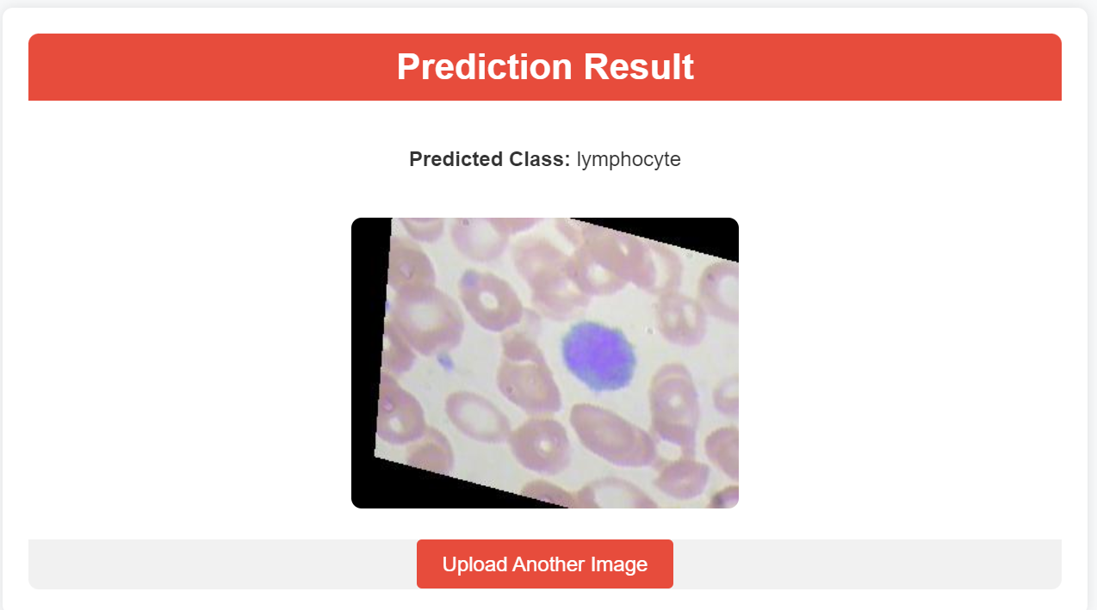

Test For Class-4 : Eosinophil

